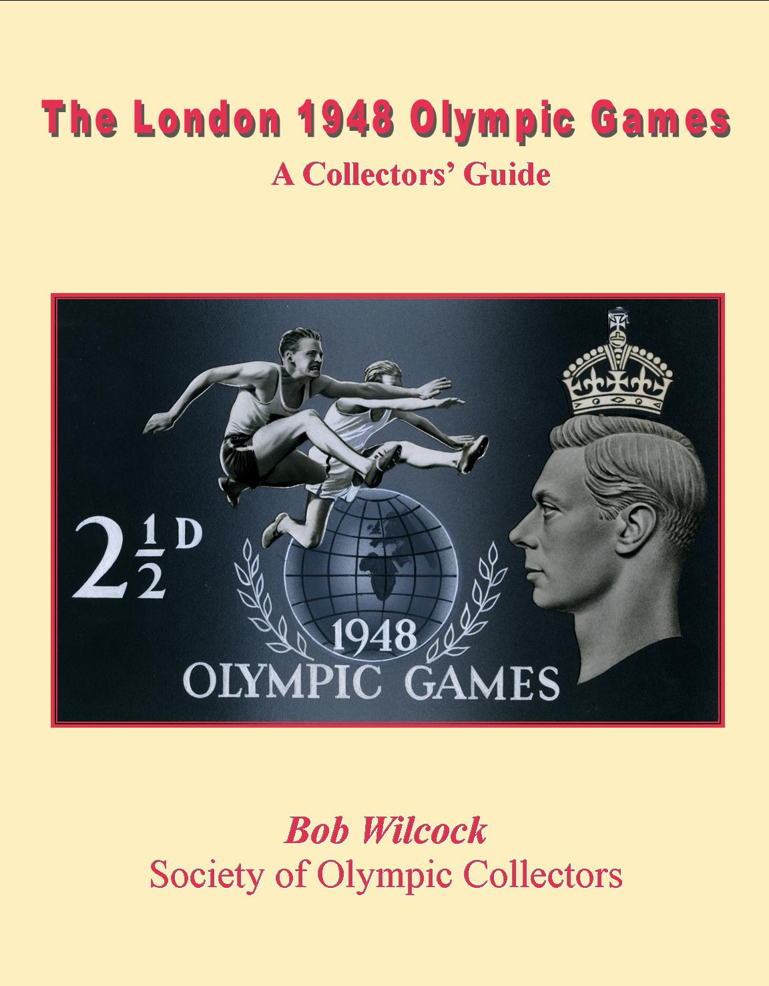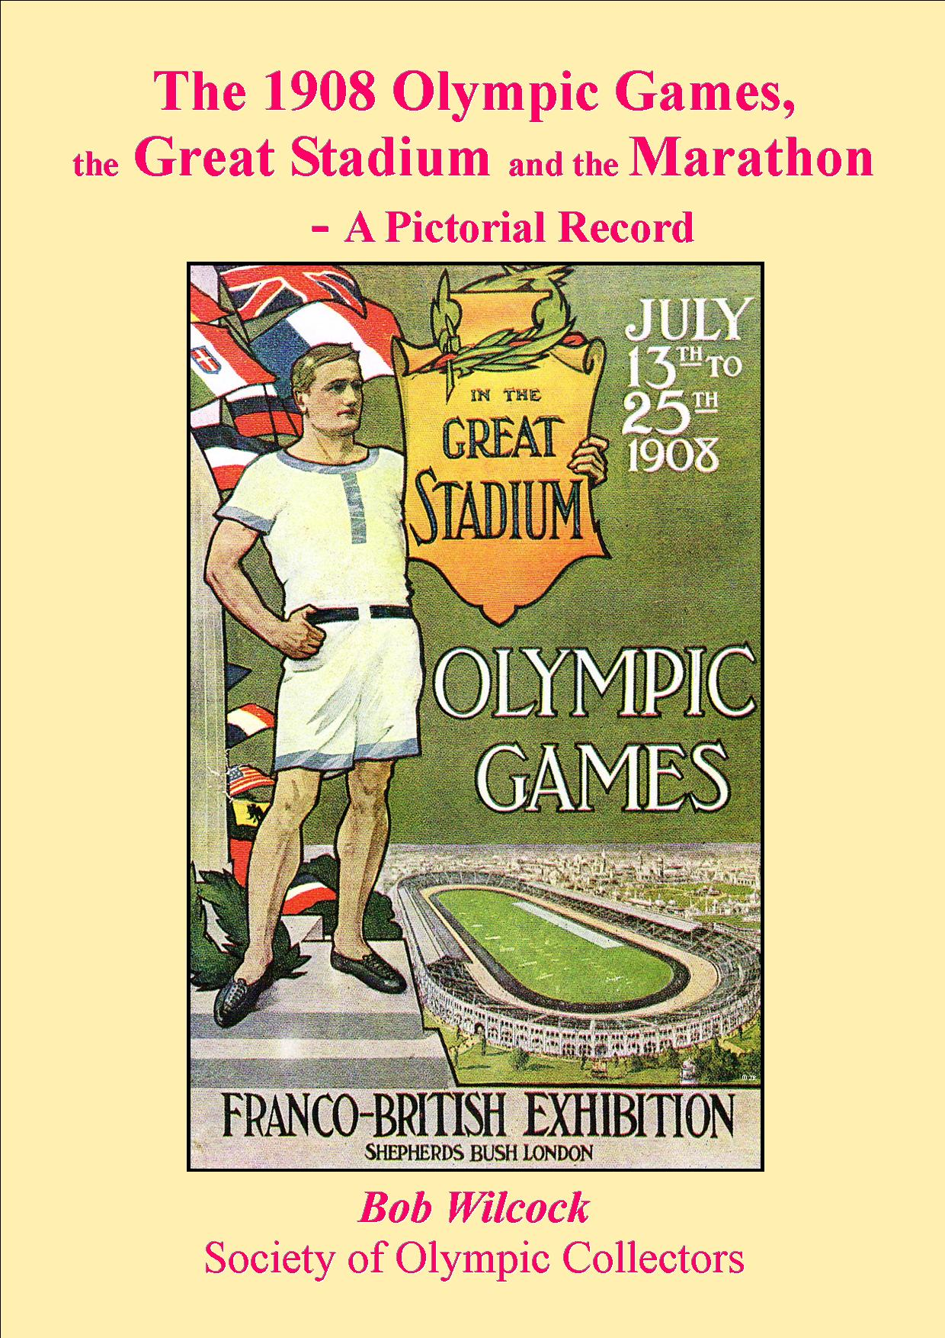

***A comprehensive guide and handbook for the collector****:*

* *The full story of the 1948 stamp issue by Douglas Muir (BPMA)*
* *All the proofs illustrated in full – including the controversial Lord Burghley design, and with original artists’ drawings*
* *The full postal history, with new discoveries and information, and including the unique postmaster’s record*
* *Olympians, medallists and ceremonies on stamps – over 200 listed and illustrated – and all the 1948 world-wide stamp issues*
* *First Day Covers, Packs, Postcards, Cigarette & Collectors’ cards, vignettes, programmes, tickets & other ephemera*
* *176 full-colour pages*
* *Invaluable to both GB and Olympic collectors*

***Price:*** *~~UK (£15 + £4 p&p) £19 post paid   
 Europe & worldwide surface £21 (€25, US$33)  
 Worldwide airmail £25 (US$40))~~*

**ISBN 978-0-9558236-1-9**

**Available from  
SOC, 24 Hamilton Crescent, Brentwood, Essex, CM14 5ES**

**~~e-mail:~~** [**~~marathon@societyofolympiccollectors.org~~**](mailto:marathon@societyofolympiccollectors.org) **~~PayPal accepted:~~** [**~~marathon@societyofolympiccollectors.org~~**](mailto:marathon@societyofolympiccollectors.org)

**\*\*e-mail** [**1908bobw@gmail.com**](mailto:1908bobw@gmail.com)

**for current prices\*\***

***** STILL AVAILABLE – LIMITED SUPPLY *****

*A complete record of all events with*

* *over 400 postcards of the Stadium, Games & Olympians   
  (100+ relating to the marathon!) listed & illustrated*
* *50 stamps relating to 1908—all in colour*
* *The full story of the marathon—the truth behind the myths  
  - the start, the finish, the distance, Conan Doyle*
* *Postmarks, postal history, vignettes.*
* *128 pages A4*

***Price:*** *~~UK £14 post paid   
 Europe & worldwide surface £16 (€20, US$30)  
 Worldwide airmail £20 (US$40))~~*

**ISBN 978-0-9558236-0-2**

**Available from  
SOC, 24 Hamilton Crescent, Brentwood, Essex, CM14 5ES**

**~~e-mail:~~** [**~~marathon@societyofolympiccollectors.org~~**](mailto:marathon@societyofolympiccollectors.org) **~~PayPal accepted:~~** [**~~marathon@societyofolympiccollectors.org~~**](mailto:marathon@societyofolympiccollectors.org)